Hrujuta Gitay
ROLL NO 65
CLASS:- BE B E&TC

#Method 1: Using 2 uppercase
<!DOCTYPE html>
<html lang="en">
<head>
<meta charset="UTF-8" />
<meta name="viewport" content="width=device-width, initial-scale=1" />
<title>Compare Strings (2 Uppercase)</title>
</head>
<body>
<h2>Compare Two Strings (Case-Insensitive using 2 Uppercase)</h2>

<label for="string1">String 1:</label>
<input type="text" id="string1" />
<br /><br />

<label for="string2">String 2:</label>
<input type="text" id="string2" />
<br /><br />

<button onclick="compareStrings()">Compare</button>

<p id="result"></p>

<script>
function compareStrings() {
const str1 = document.getElementById('string1').value;
const str2 = document.getElementById('string2').value;

// Convert both strings to uppercase
const upperStr1 = str1.toUpperCase();
const upperStr2 = str2.toUpperCase();

const result = document.getElementById('result');

if (upperStr1 === upperStr2) {
result.textContent = 'The strings are equal (case-insensitive).';
result.style.color = 'green';
} else {
result.textContent = 'The strings are NOT equal.';
result.style.color = 'red';
}
}
</script>
</body>
</html>

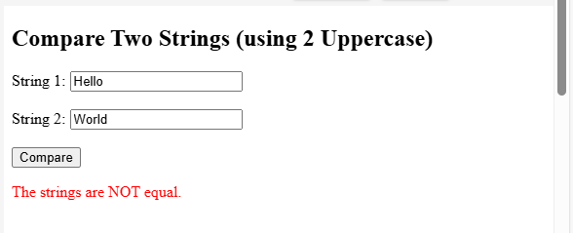

#Method 2: Using RegEx
<!DOCTYPE html>
<html lang="en">
<head>
<meta charset="UTF-8" />
<meta name="viewport" content="width=device-width, initial-scale=1" />
<title>Compare Strings Using RegEx</title>
</head>
<body>
<h2>Compare Two Strings Using RegEx </h2>

<label for="string1">String 1:</label>
<input type="text" id="string1" />
<br /><br />

<label for="string2">String 2:</label>
<input type="text" id="string2" />
<br /><br />

<button onclick="compareStrings()">Compare</button>

<p id="result"></p>

<script>
function escapeRegExp(string) {
// Escape special RegEx characters to treat input as literal string
return string.replace(/[.*+?^${}()|[\]\\]/g, '\\$&');
}

function compareStrings() {
const str1 = document.getElementById('string1').value;
const str2 = document.getElementById('string2').value;

// Escape special chars from str1 to make a safe RegEx
const escapedStr1 = escapeRegExp(str1);

// Create RegEx with ^ and $ to match entire string, with case-insensitive flag
const regex = new RegExp(`^${escapedStr1}$`, 'i');

const result = document.getElementById('result');

if (regex.test(str2)) {
result.textContent = 'The strings are equal (case-insensitive) using RegEx.';
result.style.color = 'green';
} else {
result.textContent = 'The strings are NOT equal.';
result.style.color = 'red';
}
}
</script>
</body>
</html>
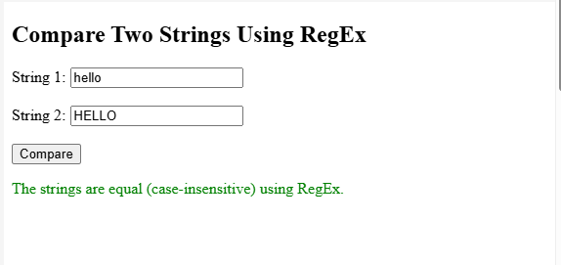

#Method 3: Using LocaleCompare
<!DOCTYPE html>
<html lang="en">
<head>
<meta charset="UTF-8">
<title>Compare Strings Using localeCompare()</title>
</head>
<body>
<h2>Compare Two Strings (Using localeCompare)</h2>

<label for="string1">String 1:</label>
<input type="text" id="string1" /><br /><br />

<label for="string2">String 2:</label>
<input type="text" id="string2" /><br /><br />

<button onclick="compareStrings()">Compare</button>

<p id="result"></p>

<script>
function compareStrings() {
const str1 = document.getElementById('string1').value;
const str2 = document.getElementById('string2').value;

// Use localeCompare with base sensitivity (ignores case and accents)
const comparison = str1.localeCompare(str2, 'en', { sensitivity: 'base' });

let message;
if (comparison < 0) {
message = `"${str1}" comes BEFORE "${str2}".`;
} else if (comparison > 0) {
message = `"${str1}" comes AFTER "${str2}".`;
} else {
message = `"${str1}" and "${str2}" are EQUAL (ignoring case and accents).`;
}

document.getElementById('result').textContent = message;
}
</script>
</body>
</html>
